**Diversity and Inclusion**

Accessibility, diversity and inclusion aligns with the Ombudsman’s vision of fair, accountable and responsive decision making and practises, and with our core value to provide our services equitably to all Western Australians.

We are committed to providing optimum access and service to people with a disability, their families and carers. Our [Disability Access and Inclusion Plan](https://www.ombudsman.wa.gov.au/Publications/Documents/daip/Disability_Access_and_Inclusion_Plan_2025-2030.pdf) 2025-2030 includes actions that considers ways to overcome obstacles to facilitate access, ensure independence, choice and control over their own lives for all those who need our services.

The actions in our Multicultural Plan 2025-2030 were developed in collaboration with our staff and consultation with organisations working with culturally, ethnically and linguistically diverse communities. The plan outlines the measures to ensure that our staff are diverse and a fair representation of our population, and guide how we meet the needs of everyone in the Western Australian community.

We welcome your ongoing feedback and suggestions to help us improve, by contacting us via email at mail@ombudsman.wa.gov.au or alternatively via any of our other [contact details](https://www.ombudsman.wa.gov.au/Contact_Us/Contact.htm).

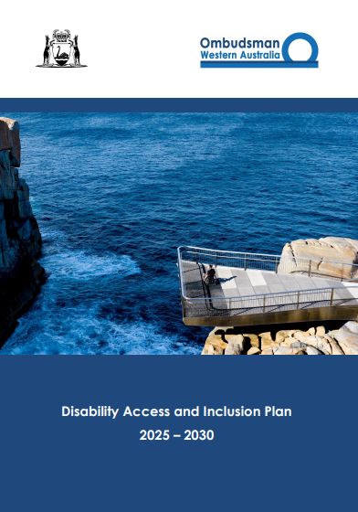 

(note: hyperlink cover images of both plans to the PDF versions.)